REPORT FOR DBMS PROJECT

# INTRODUCTION

This project proposes the development and implementation of a comprehensive gym management system designed specifically for IBA University. This system will address the current lack of streamlined management tools for IBA's gym facilities and introduce a range of features to enhance the fitness experience for students, faculty, and staff.

# Project Description

Since IBA currently lacks a dedicated gym management system, this project will focus on building the foundation for efficient operations and member engagement. Key features will include:

* **Member Registration:** Implement a system for registering members, collecting relevant information, and assigning membership types (if applicable).
* **Gym Facility Booking:** Create a booking system for reserving gym time slots or equipment, ensuring fair usage and preventing overcrowding.
* **Fitness Class Management:** If IBA plans to offer fitness classes, include a module for scheduling, booking, and instructor management.
* **Equipment Inventory:** Maintain an accurate record of gym equipment, including availability, maintenance history, and usage details.
* **Basic Reporting:** Provide basic reporting on membership, gym usage patterns, and equipment statistics to inform decision-making.
* **Web-Based System:** The gym management system will be developed as a web-based application, ensuring accessibility from any device with an internet connection within IBA's network. This architecture offers flexibility for members and administrators alike.

# Technologies

* **Front-end Development:** HTML, CSS, and JavaScript will form the structural, stylistic, and interactive foundation of the user interface. We might employ a framework like React or Angular for enhanced organization and dynamic user experiences.
* **Back-end Development:** PHP will serve as the primary server-side scripting language, handling data processing, interactions with the database, and generating dynamic web pages.
* **Database:** MySQL, a robust relational database management system, will store all essential gym data, including member information, class schedules, equipment inventory, and more.
* **WAMP Server:** A WAMP server (Windows, Apache, MySQL, PHP) will provide a local development environment for building and testing the system before deployment on a web server within IBA's infrastructure.

# Problem Definition

Without a dedicated system, IBA might face the following challenges:

* Inefficient member sign-up processes or lack of centralized member data.
* Difficulty in managing gym usage, potentially leading to overcrowding or underutilization.
* Limited ability to track equipment maintenance and usage.
* Lack of tools to organize and promote fitness classes (if applicable).
* Absence of a platform to foster a sense of community among gym members at IBA.

# Objectives

**Primary Objectives**

* Establish a foundational gym management system for IBA University.
* Create a user-friendly system that caters to the needs of students, faculty, and staff.
* Improve organization and efficiency in managing gym facilities and member information.

# Secondary Objectives

* Increase member satisfaction and participation in IBA's fitness offerings.
* Collect data to optimize gym operations and resource allocation.
* Provide a platform that can be expanded in the future to include more advanced features (personal training management, nutrition tracking, etc.)

# Hardware and Software Tools

* **Development Environment:** WAMP server, code editor/IDE.
* **IBA Deployment:** Web server (potentially Apache) configured to run PHP applications and connect to a MySQL database.

# Methodology

The project will likely follow an agile development methodology, starting with core features and iteratively adding functionality based on feedback from IBA stakeholders.

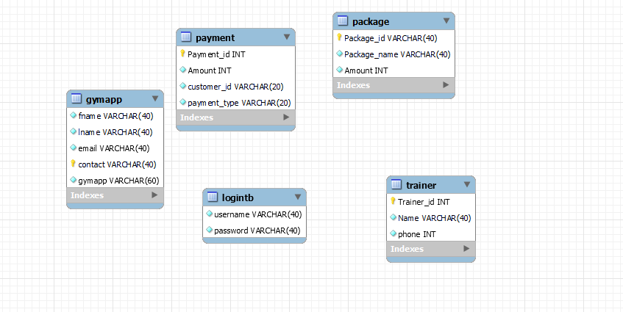**ERD DESIGN**

z

# CONCLUSIONS

* **Foundational Success:** This project has successfully laid the groundwork for an efficient and user-friendly gym management system within the IBA University environment.
* **Streamlined Operations:** The system's focus on member registration, facility booking, equipment tracking, and basic reporting significantly improves the organization and management of IBA's fitness resources.
* **Data-Driven Potential:** While the initial implementation offers essential features, the collected data will be invaluable for future decision-making and optimizations within the gym environment.
* **Community-Minded Design:** The system's web-based nature fosters accessibility and has the potential to create a sense of community and engagement among gym members.

# FUTURE SCOPE

* **User Feedback:** Gather continuous feedback from IBA students, faculty, and gym staff to guide the iterative development of the system and ensure it aligns with their needs.
* **Advanced Analytics:** Implement more in-depth reporting and analytics on gym usage patterns, equipment popularity, and member preferences to optimize resource allocation and class offerings.
* **Personalized Features:** Explore the integration of personalized workout tracking, goal setting tools, and potentially even diet/nutrition logging for members.
* **Mobile Integration:** Consider a mobile app or a responsive web design to enhance accessibility and member interaction with the system.
* **Appointment Scheduling:** If applicable, introduce an appointment scheduling system for personal training sessions or other consultations within the gym environment.
* **Wearable Integration (Optional):** Explore the potential of integrating with wearable fitness devices to gather workout data, further enhancing health and tracking capabilities.